Example RFQ from Spec document

Toyota 65PL battery Reserve Bottle
Updated 6/13/25

General:
- Part is approximately 100mm x 120mm x 265mm (l x w x h) – fairly small.
  - 2 ports (hose) - no inserts
  - Cap to be installed after test
- Molding to be 1+1 family mold.
- Cycle time: Molding @ 45 seconds
- Include data logging (to USB) of significant parameters (weld, insertion, and test)
- Option #1: Entire new cell (capital and tooling)
- Option #2: Tooling only to fit in existing cell (TOM1009)

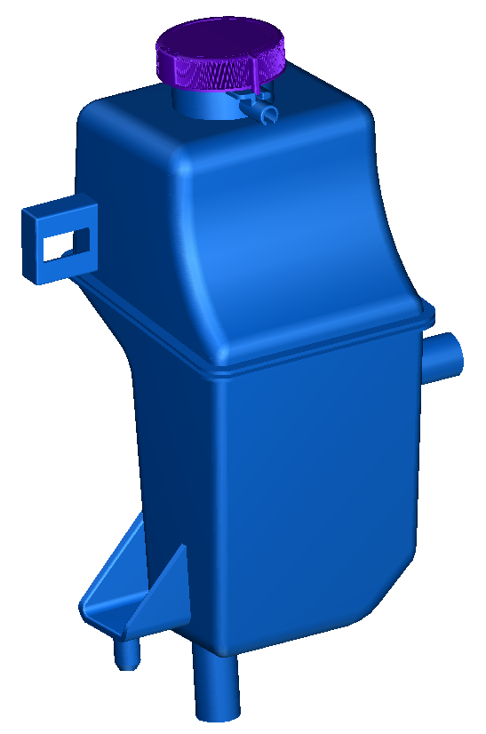
Part:

Automation:

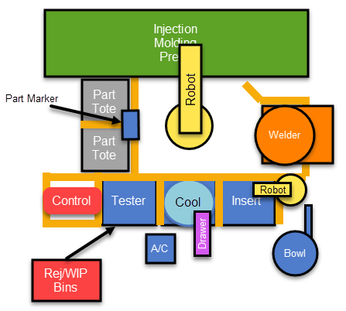
Concept:

Mold:
- Robot #1 (Fanuc) to service the mold.
  - EOAT “double sided” to tend mold and assembly stations.
- Robot #1 picks bottles from mold.
- Rejected parts from molding process (RJG) or assembly to be placed in Reject Bin
- Breakdown:
  - Tooling: Design, EOAT
  - Capital: robot, pedestal, controls

Welder:
- Robot #1 to pick & place bottles in welder.
  - Bottles will need to be “flipped” into weld position.
- New rotary table hot plate welder – similar to existing
  - Need to review size of part – similar to P552 (S2266)
  - Includes servo controls (top, bottom, and hot plate), pneumatic and electrical for nests, vacuum for upper nest.
    - 7kN capacity for top & bottom servos
  - 8 zone heat control for hot plate
  - Force Transducer for upper platen
- Weld nests
  - Profile plate in sections to allow adjustments to fit part without additional machining.
  - Slides under protrusions
  - Part ejection cylinder in upper
  - Part temperature sensor (IR) in bottom nests
- Hot plate
  - Weld plates - aluminum with Teflon coating
- Rejected part placed in Reject Bin
- Breakdown:
  - Capital: Welder (base, controls, programming)
  - Tooling: Design, Nests, Melt Plates
  - Option: 40 spare weld plates

Cooling:
- Robot #1 to pick & place bottles from cooling nests.
- 4 Nests with forced air, blowing chilled air (Move-N-Cool) into fillneck
- Breakdown:
  - Tooling: Design, Part Nests
  - Capital: Move-N-Cool, Base, Controls, etc.

Test / datecode
- Robot #1 to pick & place bottles from cooling
- Include a part temperature sensor (Raytek).
- Leak Test
  - Fillneck has a vent port, so custom fitting is required.
  - FasTest or CTS seals for 2 outlet ports.
  - Test #1, Test pressure relief port. Supply air at 15 psi. Pressure sensor to detect back pressure.
  - Test #2, leak test at TBD (assume 100 kPa), TBD sccm using LeakMaster
  - Test #1 and Test #2 can be performed simultaneously due to cycle time.
- Breakdown:
  - Tooling: Robot EOAT, Design, tooling plate, nesting, clamps, seals
  - Capital: Robot, LeakMaster, Reject bin, Laser marker and balance of equipment.

Cap installation (at Insertion station):
- Robot #1 to present bottle to torque equipment
- Bowl feeder to feed caps to deadnest
- Robot #2 (LR Mate) to move cap to bottle
- Caps rotated/torqued in place
- Breakdown:
  - Tooling: Design, tooling plate, nesting, bowl feeder, inline, cap grippers/mandrel
  - Capital: Base, controls, cap torquer

WIP:
- Drawer/nest to be able to put assembled bottles back into system for test only.
- Breakdown:
  - Tooling: Part nest
  - Capital: Drawer, Base

Packaging:
- Robot #1 to place rejected bottles in Reject Bin
- Robot #1 to hold good bottles for datecode with laser marker, place bottles in good totes.
- Positions for 2 totes (1 being filled, 1 full/empty)
  - Totes to be changed by operator.
- Breakdown: all capital

Bins
- Scrap bin with chute for robot
  - Locked access from outside of cell
- WIP bin with chute for robot
  - Access from outside of cell
- Breakdown: all capital

Sample RFQ response:

User: for the concepts, please disregard the retrofitting information and just focus on the full cell applications
ChatGPT said:
I have reviewed the RFQ document in detail. Below is a structured draft RFQ response per the template, focusing only on the full cell (Option #1) approach as you requested.

🟢 RFQ Response: Toyota 65PL Battery Reserve Bottle

1. Extract & Summarize Specifications / Requirements
Below, I have organized the provided requirements aligned to our Training Spec v1 checklist:
Category | Details
Customer Contact | Not specified. ⚠️ Must confirm.
Plant / Install Location | Not specified. ⚠️ Must confirm.
Timing / PO Date / Kickoff | Not specified. ⚠️ Must confirm project timeline and milestones.
Design Approval / FAT Requirements | Not specified. ⚠️ Must clarify expectations for design review, runoff, FAT, SAT.
Part | Reserve Bottle approx. 100mm x 120mm x 265mm; 2 ports (hose); no inserts; cap installed after test.
Part Variations / Part Numbers | Not specified. ⚠️ Must confirm if variations exist or will be introduced.
Cycle Time | Molding cycle time specified at 45 seconds.
Annual Quantity / Demand | Not specified. ⚠️ Must confirm.
Description of Requirements | Entire new cell with molding tending, welding, cooling, leak testing, cap insertion, date coding, and packaging.
Operation Steps | 1. Mold tending & part pick  2. Hot plate welding  3. Cooling with chilled air  4. Leak test (2 steps)  5. Cap installation  6. Date coding  7. Packaging
Robots Needed | - Robot #1: Fanuc (large robot) performing nearly all operations  - Robot #2: LR Mate for cap handling
Inspections / Testing | - Weld data logging  - Leak testing (2-stage)  - Date coding
Special Requirements | - Data logging to USB  - IR temperature sensing  - Custom seals and nests  - Reject bin handling
Footprint Constraints | Not specified. ⚠️ Must confirm available floor space and ceiling height.
Integration into Existing System | This approach is new cell only.
CMM Certification / RCS / Fasteners | Not specified. ⚠️ *Must confirm any standards for documentation, coatings, fasteners.
Penalties / Warranty | Not specified. ⚠️ Must confirm.
Cost Breakdown Requested | Yes, costs separated by Tooling and Capital per sub-process.
3rd Party Inspections | Not specified. ⚠️ *Must confirm (UL, OSHA, etc.).
Warranty Length Expected | Not specified. ⚠️ Must confirm.

2. Feasibility Risks
Below are potential red flags and ambiguities that must be clarified before moving to engineering:
- Plant Location / Environment: No information on installation site (space, utilities, ambient conditions).
- Cycle Time Alignment: While molding time is 45 seconds, the cumulative downstream process time (welding, cooling, leak test, capping, marking) appears similar or longer. The RFQ does not provide clear TAKT/cycle expectations per station.
- Part Handling Precision: Flipping bottles for welding and precise nesting in multiple stations will require careful EOAT design.
- Leak Test Specs Incomplete: Leak test pressures and leak rates ("TBD")—must be specified.
- Integration Requirements: No mention of MES or plant-level communications (barcode scanning, production tracking).
- Data Logging / IT: Format, frequency, and IT security policies for data logging to USB unspecified.
- Safety / Compliance: No explicit requirements for safety guarding standards, UL, CE marking.
- No confirmation of Annual Volume: Critical to determine throughput expectations and robot sizing.
- No footprint constraints provided: May impact cell design/layout.

3. Suggested Conceptual Approaches (Full Cell)
Note: All concepts assume new automation cell only.

Concept 1: Dual Robot Cell with Central Rotary Welding and Inline Process Flow
✅ Description
- Robot #1 (Fanuc) performs mold tending, welding loading/unloading, cooling, leak test loading/unloading, date coding, and good/reject handling.
- Robot #2 (LR Mate) performs cap placement and torquing.
- Inline process with rotary table hot plate welder.
- Fixed cooling nests.
- Standalone leak test station.
- Laser date marking integrated inline.
Pros:
- Fewer robots (2 total) to reduce complexity.
- Streamlined linear flow from molding to packaging.
- Reuses proven Koops approach to rotary welding (similar to P552).
Cons:
- Robot #1 highly utilized – risk of cycle time bottleneck.
- Complex EOAT with flipping and multiple nests.
- Potential for longer cycle times per part.
Feasibility Concerns:
- Confirmed leak test spec and cycle time needed to validate throughput.

Concept 2: Three-Robot Cell with Parallel Processing
✅ Description
- Robot #1 (Fanuc): Mold tending and welding only.
- Robot #2 (Fanuc LR Mate): Cooling and leak testing.
- Robot #3 (LR Mate): Cap insertion and date coding.
- Parallel stations for welding and leak test to decouple time.
- Cooling nests in-line between welding and leak test.
Pros:
- Cycle time risk mitigated by decoupling leak test and welding.
- Dedicated robot for delicate cap insertion improves reliability.
- Simplifies EOAT design (specialization).
Cons:
- Higher capital cost (additional robot).
- Larger footprint needed.
Feasibility Concerns:
- Footprint constraints unknown.
- Leak test spec TBD.

4. High-Level Bill of Materials
Below is a preliminary BOM for each concept.
(Note: quantities and suppliers are subject to detail engineering.)

Concept 1 BOM
Subsystem | Description
Robot #1 | Fanuc 6-axis robot + controller
Robot #2 | Fanuc LR Mate + controller
EOAT | Dual-sided gripper, flipping mechanism
Hot Plate Welder | Rotary table welder w/ servo platens
Cooling Station | Forced air nests, Move-N-Cool system
Leak Test Station | LeakMaster w/ custom fixtures
Cap Insertion | Bowl feeder, torque drive
Laser Marker | Inline date coder
Controls | Central PLC, HMI, safety devices
Guarding | Perimeter fencing, interlocks
Data Logging | Industrial PC w/ USB export
Packaging | Totes, reject bins

Concept 2 BOM
Subsystem | Description
Robot #1 | Fanuc 6-axis robot + controller
Robot #2 | Fanuc LR Mate + controller
Robot #3 | Fanuc LR Mate + controller
EOAT | Specialized grippers per robot
Hot Plate Welder | Rotary table welder w/ servo platens
Cooling Station | Forced air nests, Move-N-Cool system
Leak Test Station | LeakMaster w/ custom fixtures
Cap Insertion | Bowl feeder, torque drive
Laser Marker | Inline date coder
Controls | Central PLC, HMI, safety devices
Guarding | Perimeter fencing, interlocks
Data Logging | Industrial PC w/ USB export
Packaging | Totes, reject bins

5. Follow-Up Questions
The following must be answered before proceeding:
- Customer Contact and Install Site
  - What is the plant location and environment (floor space, utilities, ceiling height)?
  - Who is the primary project contact?
- Timing
  - Confirm project milestones: PO date, kickoff, design approval, FAT, SAT.
- Cycle Time & Volume
  - What is the target TAKT time per finished part?
  - What is the annual production volume?
- Leak Test Specification
  - Confirm leak test pressure (Test #2): currently TBD kPa.
  - Confirm leak rate threshold (sccm): currently TBD.
- Data Logging
  - What file format, frequency, and retention policy for USB data logging?
- Integration Requirements
  - Will this system need MES connectivity, barcode tracking, or ERP interfaces?
- Footprint
  - Are there any constraints on footprint or height?
- Compliance
  - Any specific 3rd-party inspections (UL, OSHA)?
  - Required documentation packages (CMM certification, manuals)?
- Standards
  - Any preferences for coatings (RCS), fastener types, warranty expectations?

Please review this draft carefully.
When ready, I can help you:
- Revise the concepts,
- Develop budgetary pricing,
- Refine the BOM detail,
- Draft customer-facing presentations.
Would you like to proceed with refining this or clarifying outstanding questions?

